**Marketplace Builder Hackathon Day2:**

**Type of Market Place: Q-Commerce:**

**Our Goal:**

Our goal is to make ordering food super easy & fast, with live delivery, tracking and a smooth user experience.

**Fronted Requirements:**

**Home Page:** A visually appealing homepage showcasing various categories of food items.

**Navigation:** Easy to use navigation bar for all categories and serach functionality.

**Product Display:** Clean and organized product grids with images and price.

**Shopping Cart:** A cart icon that updates when items are added,allowing user to view their order before checkout.

**Check-out:** Customer info, shipping and payment options.

**Order Confirm:**Order summary and tracking. **Responsive Design:**Optimized for all screen.

**Backend Requirements:**

Sanity CMS used as the backend for marketplace allows you to manage all types of details.

**Product Data:** Create schemas for product with field.Easily update product listing through the CMS interface.

**Customer Data:** Manage customer profiles including contact info and order history.

**Order Records:** store and track order details, shipping information and payment status.

**Third-Part APIs:**

**Shipping Tracking:** Use APIs for real time shipping rates and tracking .

**Payment gateways:** Integrated APIs like stripe or paypal for secure transaction.

**System Architecture:** 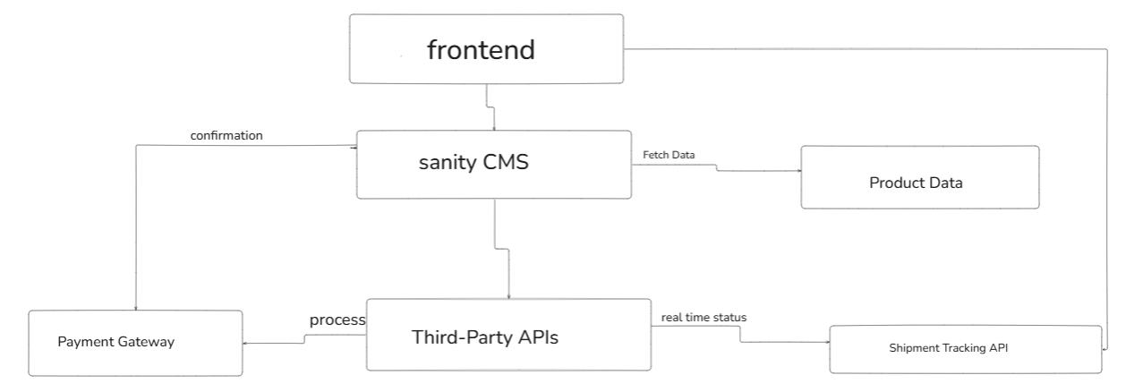

**Work flow Description:**

**User Browsing Products:**

* The user opens the website (made with Next.js).
* The website gets All the food details from sanity CMS.
* Food items are shown instantly for the user to browse.

**Placing the order :**

* The user fixed your food at it to the card and check out.
* Payment is completed through a secure online gateway.

**Tracking the Delivery:**

* The other status is updated using the delivery API.
* The user can see we are the delivery person is in real time.

**API End points:**

|  |  |  |  |
| --- | --- | --- | --- |
| End Point | Method | Description | Parameters |
| /api/foods | GET | Fetch all food items | None |
| /api/foods/:id | GET | Fetch a single food | Id(path) |
| /api/foods | POST | Add a new food | Name,price,category |
| /api/foods/:id | PUT | Update food | Id,name,price |
| /api/foods/:id | DELETE | Delete food | Id |
| /api/category | GET | Fetch category | None |

**Sanity CMS schema:**

**Product schema:**

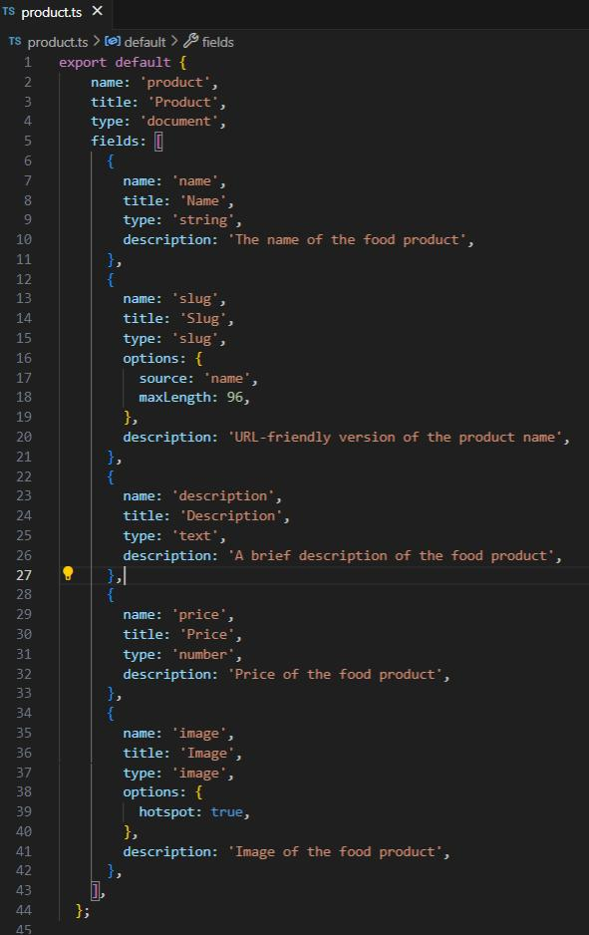**Order Schema:**

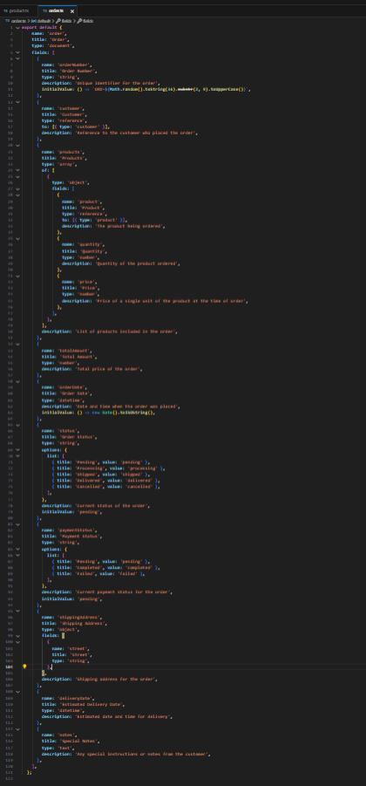

**Flow Diagram:**

